October-November 2005

This Newsletter is archived in the website www.irlandeses.org, at the "Members Only" restricted area. To access "Members Only" please type the following data:
User Name: member
Password: dublin
(the system is case-sensitive)

Contents
- New Members
- Art Agnew Honorary Member
- New Databases: Sisters of Mercy and Bolivar B&I Soldiers
- SILAS Website in Richard Slatta's paper
New Members
We are pleased to announce the following new memberships to the Society: Art Agnew (Honorary Member), Catherine Jennings and Ciarán O'Muirí (Senior Mermbers). The Society has 67 Members.
Art Agnew Honorary Member
Art Agnew, the Irish Ambassador to Mexico, is the latest appointment to SILAS Honorary Membership. Being accredited to Mexico since 1999 Mr. Agnew is now retiring from an extensive career as a diplomatist, which included a four-years assignment as Ambassador to Argentina.
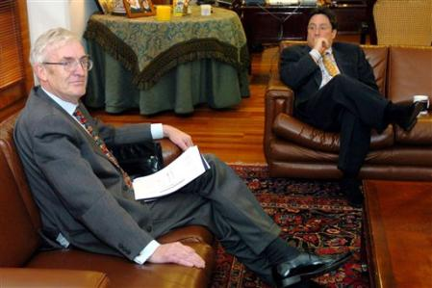
Ambassador Art Agnew
(AP Photo/Zoe Selsky)
New Databases
Two new lists have been added to the databases available exclusively to SILAS Members. The "Sisters of Mercy in Argentina" (140 records) includes founding sisters of the community in that country, and sisters who professed locally. It was transcribed from an Appendix in Santiago M. Ussher's "Las Hermanas de la Misericordia (Irlandesas): Apuntes históricos sobres sus cien años en la Argentina, 1856 - Febrero 24 - 1956" (Buenos Aires, 1955). The second one, "British and Irish Soldiers in Bolívar's Army of Independence" (670 records) includes Soldiers enlisted in England and Ireland by recruiters on behalf of Simón Bolívar to fight in Venezuela, Colombia, Ecuador, Peru and Bolivia. It was compiled from information in Alfred Hasbrouck's "Foreigns Legionaries in the Liberation of Spanish South America" (New York: Columbia University, 1928). To access these databases please go to our website (www.irlandeses.org) and click on "Members Only" using the User Name and Password mentioned above.
SILAS Website Cited in Academic Paper
"Irish Migration Studies in Latin America" is being increasingly used by students and scholars to teaching and researching the Irish Diaspora. Professor Richard Slatta North Carolina State University (author of "Gauchos and the Vanishing Frontier" among other books) and E. Kalé Haywood recently published “Enhancing Latin American History Teaching and Research with Computers” (Social Science Computer Review, 23: 2, Summer 2005, pp. 152-66), using SILAS website as one of the examples.
A pdf version of this papers is available online (http://ssc.sagepub.com/cgi/content/abstract/23/2/152).

