December 2004 - January 2005

- New Members
- Restricted Area in the Website
- Manuscripts and Rare Books Collection
- Irish Argentine Research Fund 2005-2006
- Website Number of Visits
- Membership Fees
New Members
I am pleased to announce the following new memberships to the Society: Edward Walsh, Patrick Fitzpatrick, and Susan Wilkinson (Senior Members). The Society has 53 Members.
Now the Databases and Files are Available in the Website
Following the request of many Members, the IAHS emigrant databases and previous issues of Members Only publication are now available in a restricted area exclusively for IAHS Members. To access please follow this simple directions:
1. Enter the url: http://www.irishargentine.org/restricted
2. Enter the User Name: member
3. Enter the Password: dublin

The password will be changed periodically and will be communicated through this medium.
The IAHS announces the creation of the Manuscripts and Rare Books Collection
As was previously communicated, from 1 January 2005 an agreement between the IAHS and the Max von Buch Library of the Universidad de San Andrés (Buenos Aires) will allow the IAHS to receive donations of letters, memoirs, estancia diaries, photographs, and other personal papers, as well as first editions of books and publications. This library is equipped with modern technology to provide proper conservation to manuscripts, and is managed by specially-trained personnel. Furthermore, the library already holds important collections of the English-speaking communities in Argentina, for instance, The Standard and 'The Strangers' Club' records. See more information about the library in www.udesa.edu.ar (Home > Biblioteca > Colecciones Especiales y Archivos). If you wish to donate family or other documents that you consider worth of sharing with researchers worldwide, please contact the Secretary (edmundo.murray@irishargentine.org).
Irish Argentine Research Fund 2005-2006
Students and researchers need your help! We are already receiving donations to next year's grant programme, which will be launched in the first quarter of 2005. This programme allows students of relations between Ireland and Latin America to continue their research or to pay for travel expenses to distant archives. Professor Rosa González Casademont (University of Barcelona, Spanish Association for Irish Studies) has accepted to sit on the Selection Committee. For this year's version, the grants were possible thanks to the generosity of the following IAHS Members and friends: David Barnwell,
Thomas Ganly, Cathal McGoey, Peter Mulvany, Edmundo Murray, The MacGeoghegan Family Society.
An individual donation of 200 euros by 10 members would make possible the continuation or initiation of at least 3 new research projects on the Irish in Latin America. If you wish to contribute with the Irish Argentine Research Fund please contact the Secretary upon receipt of this newsletter (edmundo.murray@irishargentine.org).
Website: Drop in the Number of Visitors
Due to technical problems in the implementation of the new design, the website "Irish Migration Studies in South America" (www.irishargentine.org) was not available for many days of November and the visits dropped to the levels of early 2004. However, visits began to increase on a daily basis and we expect that in December they will reach normal levels.
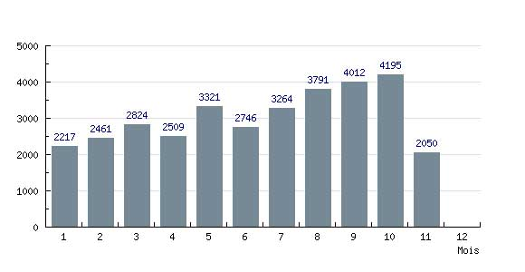
IAHS Website: results to 30 November 2004 (4:30pm)
Major features under evaluation for the next edition (January-February 2005) include a Special Edition about the 200th Anniversary of the birth of Fr. Anthony Fahy (11 January 2005 - 20 February 1871):
* Fr. Anthony Fahy O.P., by Edward Walsh
* Anthony Fahy of Loughrea: Irish Missionary in Argentina, by Michael Fahy
* Dictionary of Irish-Argentine Biography. Anthony Dominic Fahy
2004 Membership Fees
Fees for year 2005 are now due. Membership fees are 20 Euros (Senior) and 10 Euros (Students), or the equivalent in Swiss Francs, Pounds Sterling, US Dollars or Argentine Pesos. In Europe, the best way to pay is to send a note in any currency via the post. In Argentina, you may pay at Guillermo MacLoughlin's office (Florida 470 2° of. 213, 10.00am to 6.00pm, phone 4328-9656). From any country, electronic transfers to IAHS's bank account are the best solution. Transfer codes are as follows:
IBAN: CH92 0027 9279 2425 7801 P
SWIFT: (BIC) UBSWCHZH80A

Please write to edmundo. murray@irishargentine.org if you have questions or comments.

Please accept our best wishes for this Holidays Season, and a very Happy New Year 2005.

Edmundo Murray
The Secretary
Irish Argentine Historical Society

