October/November 2004

- New Members
- Irish Argentine Research Fund 2005-2006
- Website: Record Number of Visitors
- Library Sources: Agreements with the Universities of San Andrés and Buenos Aires
- Membership Fees
New Members
I am pleased to announce the following new memberships to the Society: Patricio MacDonagh, Marguerite Cleary (Senior Members), Eileen Gibbs, and Anthony Riseley (Student Members). The Society has 50 Members.

Irish Argentine Research Fund 2005-2006
We are already receiving donations to next year's grant programme, which will be launched in the first quarter of 2005. This programme allows students of relations between Ireland and Latin America to continue their research or to pay for travel expenses to distant archives. Professor Rosa González Casademont (University of Barcelona, Spanish Association for Irish Studies) has accepted to sit on the Selection Committee for next year. For this year's version, the grants were possible thanks to the generosity of the following IAHS Members and friends:
David Barnwell
Thomas Ganly
Cathal McGoey
Peter Mulvany
Edmundo Murray
The MacGeoghegan Family Society
An individual donation of 200 euros by 10 members would make possible the continuation or initiation of at least 3 new research projects on the Irish in Latin America. If you wish to contribute with the Irish Argentine Research Fund please contact the Secretary upon receipt of this newsletter (edmundo.murray@irishargentine.org).
Website: Record Number of Visitors
For the first time, the website "Irish Migration Studies in South America" (www.irishargentine.org) attracted almost 4,000 visits in a thirty-days period. To date, current year's results averaged 3,004 visitors per month.
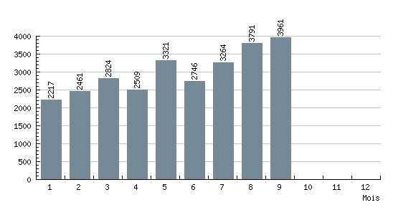
IAHS Website: results to 30 September 2004 (4:00pm)
Major features under evaluation for the next edition (November 2004) include:
- The Life of an Irish International Anarchist: Dr. Juan Creaghe of Luján (1841-1920), by Máirtín Ó Catháin (title to be confirmed).
- The Black Frigate ('Hercules', the flagship of Admiral Brown's armada), by Eduardo Gerding.
- Voices from the Camps. New sound files of Bill Meek interviews in 1987 with Mrs. Casey of Duggan Town, Mrs. Mackay, Mrs. Sills of San Antonio de Areco (II), Eduardo Coghlan, Hilda Sabato, and Maria Elena Walsh.
Library Sources: Agreements with the Universities of San Andrés and Buenos Aires
A repository agreement between the IAHS and the library of the Universidad de San Andrés (Buenos Aires) will allow the IAHS from the end of 2004 to receive donations of letters, memoirs, estancia diaries, photographs, and other personal papers as well as old editions of books and publications. This library is equipped with the latest available technology to provide the best possible conservation to manuscripts, and is managed by specially-trained personnel. Furthermore, the library already holds important collections of the English-speaking community in Argentina, for instance, The Standard and The Strangers' Club records. Additionally, other agreement with Instituto Ravignani of the Universidad de Buenos Aires (to be confirmed) will allow to digitalise partially or totally some of these documents to make them available in electronic files or through the IAHS website.
If you wish to donate family or other documents that you consider worth of sharing with researchers worldwide, please contact the Secretary (edmundo.murray@irishargentine.org).
2004 Membership Fees
Fees are due as from January 1st 2004. Membership fees are 20 Euros (Senior) and 10 Euros (Students), or the equivalent in Swiss Francs, Pounds Sterling, US Dollars or Argentine Pesos. In Europe, the best way to pay is to send a note in any currency via the post. In Argentina, you may pay at Guillermo MacLoughlin's office (Florida 470 2° of. 213, 10.00am to 6.00pm, phone 4328-9656). From any country, electronic transfers to IAHS's bank account are the best solution. Transfer codes are as follows:
IBAN: CH92 0027 9279 2425 7801 P
SWIFT: (BIC) UBSWCHZH80A

Please write to edmundo. murray@irishargentine.org if you have questions or comments.

Best wishes,

Edmundo Murray
The Secretary
Irish Argentine Historical Society

