1 August 2004

- New Members
- Grant Recipients of the Irish Argentine Research Fund 2004-2005
- 'The Irish in South America' Panel in ACIS Conference and the first non-virtual meeting of the IAHS in Liverpool
- Website Statistics and September 2004 Contents
- Membership Fees and Donations
New Members
I am pleased to announce the following new memberships to the Society: Gera Burton, Augusto Whelan, Alan Coghlan, Seamus Mulvey, and Eugene Ó Carroll, all of them Senior Members. The Society has 46 Members (please see list in the last page).

Grant Recipients of the Irish Argentine Research Fund 2004-2005
We are very pleased to announce that the Selection Committee (Kevin Whelan, Hilda Sabato, and Oliver Marshall) have selected the following research projects:
- Claire Healy (National University of Ireland, Galway), 600 Euros, 'Irish Migration to Argentina: Interaction between African, Indigenous and Irish People in Buenos Aires, 1776-1892.'
- Jorge Cernadas Fonsalías (Universidad de Buenos Aires), 400 Euros, 'Relations Between the Irish Nationalist Movement and the Irish settlers in Argentina, 1916-1922.'
- Helen Kelly (Trinity College, Dublin), 400 Euros, 'An Historical Analysis of the Irish Community in Argentina from 1830s to the Turn of the Century.'
- Maria Jose Roger and Lorena Kijora (Universidad Católica Argentina), 300 Euros, 'The Irish Argentines during the Violent Years, 1976-1983. The Role of the Irish-Argentine Institutions and Individuals during the Last Military Dictatorship in Argentina.'
- Carla Horton (Universidad de Buenos Aires), 200 Euros, 'En Defensa de los Valores de la Raza Irlandesa. El Padre Federico Richards y el Southern Cross ante el Proceso de Reorganización Nacional, 1976-1978.'
These grants were possible thanks to the generosity of the following IAHS Members and friends:
David Barnwell
Thomas Ganly
Cathal McGoey
Peter Mulvany
Edmundo Murray
The MacGeoghegan Family Society
We will launch our the next grants in February 2005, and we hope to count with your support for this successful programme.
Website Statistics and September 2004 Contents
The website "Irish Migration Studies in South America" (www.irishargentine.org) continues to attract visitors. To date, current year's results averaged 2,714 visitors per month.
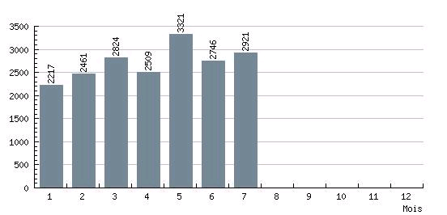
IAHS Website: results to 28 July 2004 (5:00pm)
Major features that we are evaluating for the next edition (September 2004) include:
- The Bradys of Giles, Areco and Westmeath, by Edward Walsh
- The Politics of the Irish Argentines, by Sergio Kiernan (title to be confirmed)
- An Irish Anarchist in Argentina: John O'Dwyer Creaghe, by Martin Ó Catháin (title to be confirmed)
2004 Membership Fees
Fees are due as from January 1st 2004. Membership fees are 20 Euros (Senior) and 10 Euros (Students), or the equivalent in Swiss Francs, Pounds Sterling, US Dollars or Argentine Pesos. In Europe, the best way to pay is to send a note in any currency via the post. In Argentina, you may pay at Guillermo MacLoughlin's office (Florida 470 2° of. 213, 10.00am to 6.00pm, phone 4328-9656). From any country, electronic transfers to IAHS's bank account are the best solution. Transfer codes are as follows:
IBAN: CH92 0027 9279 2425 7801 P
SWIFT: (BIC) UBSWCHZH80A

Please write to edmundo.murray@irishargentine.org if you have questions or comments.

Best wishes,

Edmundo Murray
The Secretary
Irish Argentine Historical Society

