1 June 2004
- New Members
- Paper in SLAS Conference in Leiden
- Dinner with IAHS Members in Buenos Aires
- Website Statistics and May 2004 Contents
- The Irish Argentine Research Fund
- Membership Fees are Now Due
- Call to General Meeting 13 July 2004
New Members
I am pleased to announce the following new memberships to the Society: Patrick Daly, Patrick Nally, Herman Beuk, Bill Meek, Dedier N. Marquiegui, Paula Slattery, Eugene McElroy, Gerard Russell, Tom Williams, and Gerard O'Connor (senior members), Ana Castello and Nancy Connolly (student members). The Society has 41 Members (list attached).
Paper Presented in SLAS Conference in Leiden, The Netherlands
On 3 April 2004, in the panel Inter-Cultural Encounters: Immigrants and their Latin American Hosts, E. Murray presented a paper about Irish-Argentine literature.
Dinner with IAHS Members in Buenos Aires
On 6 May 2004, in a dinner presided by the Irish Ambassador Paula Slattery and organised by Asociación Irlandesa Argentina, the following members met in Club del Progreso: Juan Pablo Alvarez, Mónica Barry, Carla Batezzatti, Gonzalo Cané, Ana Castello, Guillermo MacLoughlin, Edmundo Murray, Hilda Sabato, and Paula Slattery.
Website Statistics and July 2004 Contents
The website "Irish Migration Studies in South America" (www.irishargentine.org) continues to attract visitors. Current year's results averaged 2,666 visitors per month vs. 442 in 2003.
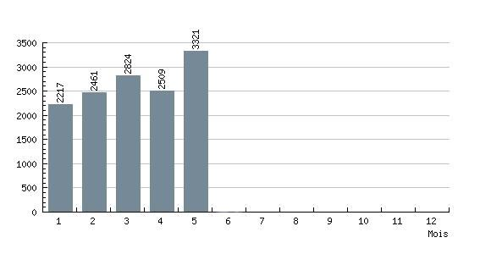
Major features of the next edition (1 July 2004) include:
- The Voices of the Irish Argentines. Sound files of 1987 RTÉ interviews by Bill Meek (to be confirmed)
- In the Name of Power: Culture and Place Names in Venado Tuerto, by Alejandra García and Gladis J. Mignacco
- New Biographies: Edward Lennon, Eduardo MacLoughlin, John Thomond O'Brien, Juan A. O'Farrell, Peter Sheridan
The Irish Argentine Research Fund
The first edition of this grant programme was launched internationally and research proposals are being received up to 14 June 2004.
Call to General Meeting 13 July 2004
The 2004 IAHS General Meeting will be held in Liverpool on 13 July 2004 at 12.30 (location to be confirmed). Decisions will be circulated to all members and absent members will be able to vote through email.

According to Article 7 of the IAHS Constitution, the following items shall be discussed and approved:
- Annual Report of the Executive Committee (will be distributed before the meeting)
- Treasurer's Report and Auditor's Report (idem)
- Executive Committee and Auditor/s: were appointed by the General Meeting in 2003, so they remain in office until 2006
- Any other business, including comments or motions from any Member present

Only Senior Members who have paid their membership fees may vote at the General Meeting (Article 6.b).
2004 Membership Fees
Fees are due as from January 1st 2004. Membership fees are 20 Euros (Senior) and 10 Euros (Students), or the equivalent in Swiss Francs, Pounds Sterling, US Dollars or Argentine Pesos. In Europe, the best way to pay is to send a note in any currency via the post. In Argentina, you may pay at Guillermo MacLoughlin's office (Florida 470 2° of. 213, 10.00am to 6.00pm, phone 4328-9656). From any country, electronic transfers to IAHS's bank account are the best solution. Transfer codes are as follows:
IBAN: CH92 0027 9279 2425 7801 P
SWIFT: (BIC) UBSWCHZH80A

Please write to edmundo.murray@irishargentine.org if you have questions or comments.

Best wishes,

Edmundo Murray
The Secretary
Irish Argentine Historical Society

