Members Only
29 March 2004

- New Members
- Claire Healy's paper in Cambridge
- Latin American Studies Conference in Leiden, The Netherlands
- Book Presentation and Dinner in Buenos Aires
- New Database: Extended Landowners
- Website Statistics and May 2004 Contents
- The Irish Argentine Research Fund
- Membership Fees are Now Due
New Members
I am pleased to announce two new members to the Society: Carla Batezzatti (student) and Graham Davis (senior). Ms. Batezzatti (indiana2208@yahoo.com.ar) is a graduate student in Buenos Aires. She is researching early diplomatic relations between Ireland and Argentina in the first decades of the nineteenth century. Dr. Davis (g.davis@bathspa.ac.uk) is the author of "Land! Irish Pioneers in Mexican and Revolutionary Texas" (Texas A&M University Press, 2002), a book about the Irish settlements in San Patricio and Refugio Texan counties with amazing parallels with the Irish in Argentina. He teaches history and Irish studies at Bath Spa University College in Newton Park, England. A warm welcome to Carla and Graham.
Claire Healy's Paper in Cambridge
On 14-22 March, during the Atlantic History Seminar at University of Cambridge ("The Atlantic World in Motion: Atlantic Diasporas, Regional Mobility, and the Mingling of Peoples, 1500-1825"), IAHS member Claire Healy from NUI Galway presented her paper "English Faces at the Port: Atlantic Networks in Buenos Aires, 1776-1825".
Latin American Studies Conference in Leiden, The Netherlands
Organised by the Society for Latin American Studies (SLAS), the Anniversary Annual Conference 1964-2004 will be held in Leiden, The Netherlands. The panel "Inter-Cultural Encounters: Immigrants and their Latin American Hosts" includes the paper "How the Irish became 'gauchos ingleses:' diasporic models in Irish-Argentine literature" by IAHS member E. Murray. Claire Healy will be there too.
Book Presentation and Dinner in Buenos Aires
On Wednesday, 5 May at 6.30 pm the book "Devenir irlandés: Narrativas íntimas de la emigración irlandesa a la Argentina, 1844-1912" will be presented by Eudeba Buenos Aires University Press in La Feria del Libro of Buenos Aires. An introduction by Dr. Hilda Sabato and a lecture by the author E. Murray will follow.

The day before, 4 May at 7.30pm a panel and dinner will be held at Club del Progreso, Buenos Aires. IAHS members are cordially invited (many thanks to Gonzalo Cané for the organization).
New Database: Extended Landowners
The original Landowners Database has been increased to 1,113 records. A new source has been added, using Edelberg's "Lista de Propietarios de la Provincia de Buenos Aires" (1922). This and other databases are available free of charge exclusively to IAHS members.
Website Statistics and May 2004 Contents
Visits to the "Irish Migration Studies in South America" website continue to grow. Compared to 556 visits in December 2003, we received 2,564 visits in March 2004 (to date). Though we did not email any update in March, St. Patrick's Day and the visit of Irish President Mary McAleese to South America were new incentives to visit our pages.
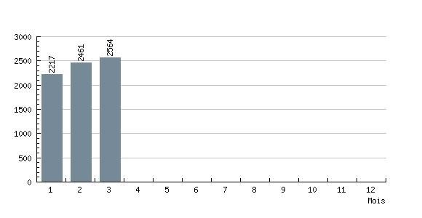
New website contents for May 2004 include the article "The First Irish Race Congress in South America" by Carolina Barry, the new landowners database in html format, and six new biographies (see prototype home page in www.irishargentine.org/index040501.htm).
The Irish Argentine Research Fund
First proposals are been received. The Selection Committee members are Kevin Whelan (chair), Hilda Sabato and Oliver Marshall. Submissions are due on 14 June 2004.
2004 Membership Fees are Now Due
For those of you who still have to pay your 2004 fees, please note that they are due as of January 1st 2004. Fees are 20 Euros (Senior) and 10 Euros (Students), or the equivalent in Swiss Francs, Pounds Sterling, US Dollars or Argentine Pesos.

In Europe, the best way to pay is just sending a note in any currency via the post. In Argentina, you may pay at Guillermo MacLoughlin's office (Florida 470 2° of. 213, 10.00am to 6.00pm, phone 4328-9656). From any country, electronic transfers to IAHS's bank account seem to be the best solution. Transfer codes are as follows:
IBAN: CH92 0027 9279 2425 7801 P
SWIFT: (BIC) UBSWCHZH80A

Please write to edmundo.murray@irishargentine.org if you have questions or comments.

With every good wishes,

Edmundo Murray
The Secretary
Irish Argentine Historical Society

